DSO 562 Project 2 Report

Detecting Fraud in the Production Applications Dataset

Team 4
Chong Li
Jie Chen
Raman Deep Singh
Xiaowen Zhang
Yu Dong

Contents

1 Executive Summary 3
2 Data Overview 4
2.1 Description of some important variables 4
3 Variable Construction 8
3.1 Type I variables 8
3.2 Type II variables 9
There are a total of 4 Type II variables. 9
3.3 Handling Frivolous values 10
4 Fraud Algorithm 11
4.1 Principal Component Analysis (PCA) 11
4.2 Calculation of fraud scores 13
4.2.1 Autoencoder 13
4.2.2 Heuristic Algorithm 13
5 Results 14
5.1 Insights 16
5.2 In-depth analysis of Top 10 records 17
6 Appendix 20
6.1 Data Quality Report 20
6.1.1 Summary 20
6.1.2 Fields Explanation 21

Executive Summary

This report provides an analysis and evaluation of Data for detecting fraud using unsupervised machine learning methods. The tools used are R and Tableau, and methods for analysis include Principal Component Analysis and Autoencoder.

The original data set. The general process of analysis follows building expert variables, standardization and dimensionality reduction, applying fraud algorithm, calculating fraud score, and identifying potential fraud.

Using heuristic fraud algorithm and autoencoder, a fraud score is calculated for each of. Records with high scores are determined to be potentially fraudulent. The report further finds the high score records of two unsupervised machine learning methods overlapped, and determines that the overlapped part of the top records from both methods are very likely to be fraudulent.

Detailed examination of the most suspicious records indicates that [insights]

Data Overview

Production Application Data is a dataset containing the records of 100,000 product applications. It includes information about the date the application made, and the SSN number, name, address, zip code, date of birth and home phone number that each applicant self-reported. These columns are all considered to be categorical variables.

Following is description of the variables we consider to be the most important. The complete Data Quality Report can be found in appendix.

Description of some important variables

Field Name: ssn

Description:

“ssn” is a categorical variable, indicating the applicant’s ssn number he or she self-reported.

Unique Values:

100% populated with 96,535 unique values. Values in this field have lengths from 4 to 9. A ssn shorter than 9 digits indicates there are leading 0s in the ssn record. For example, ssn record “2503” is actually “000002503”. The top 10 frequent appeared ssn records are shown below. It is obvious that the ssn record “737610282” is a frivolous record, which appears 173 times more than the second highest appeared record.

The top 10 most frequent records are listed below:

SSN | Frequency
737610282 | 1.73%
938972725 | 0.01%
810776805 | 0.01%
829352390 | 0.01%
473311863 | 0.00%
189622157 | 0.00%
163830210 | 0.00%
407447121 | 0.00%
118692079 | 0.00%
849295926 | 0.00%

The distribution of the top 10 records (excluding the most frequent record “737610282”):

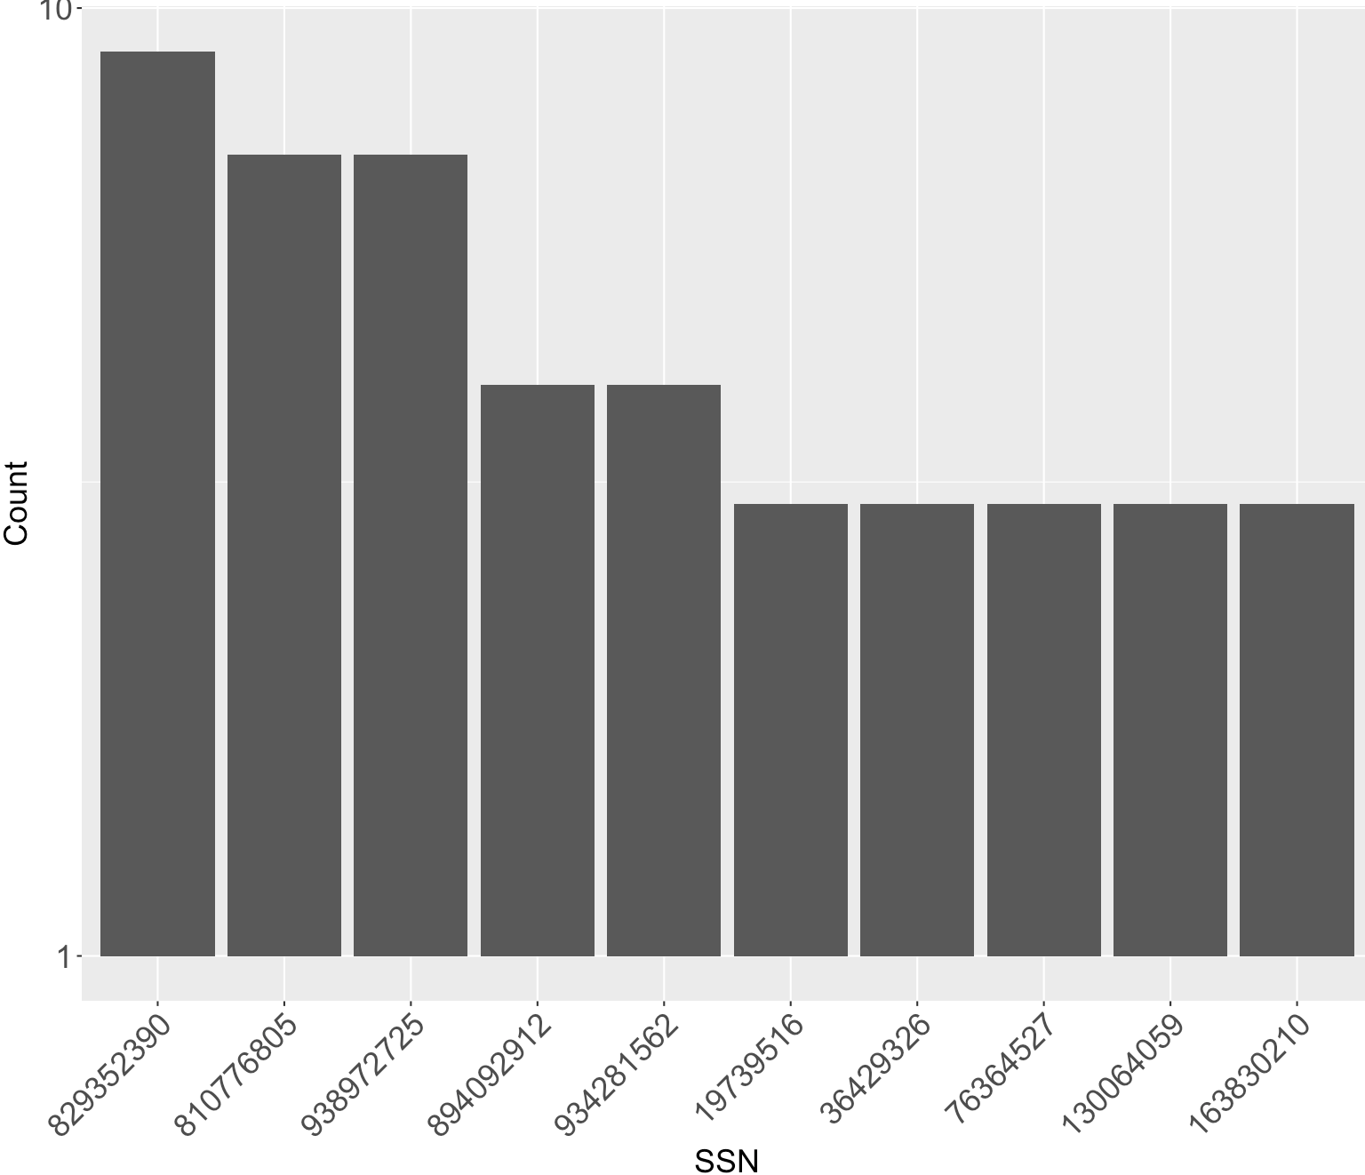

Field Name: dob

Description:

“dob” is a date variable that contains inputs from applicants of their date of birth.

Unique Values:

100% populated with 36,816 unique values from 100,000 records. No missing values. The most frequent date of birth “19070626” appeared 12,488 times, which accounts for 12.49% of all records. This date of birth is likely to be a frivolous value.

The top 10 most frequent records are listed below:

dob | Frequency
19070626 | 12.49%
19640318 | 0.51%
19760625 | 0.34%
19880628 | 0.15%
19740216 | 0.09%
20090127 | 0.02%
19000210 | 0.01%
19670215 | 0.01%
20010904 | 0.01%
19460901 | 0.01%

The distribution of the top 10 records (excluding the most frequent record “19070626”):

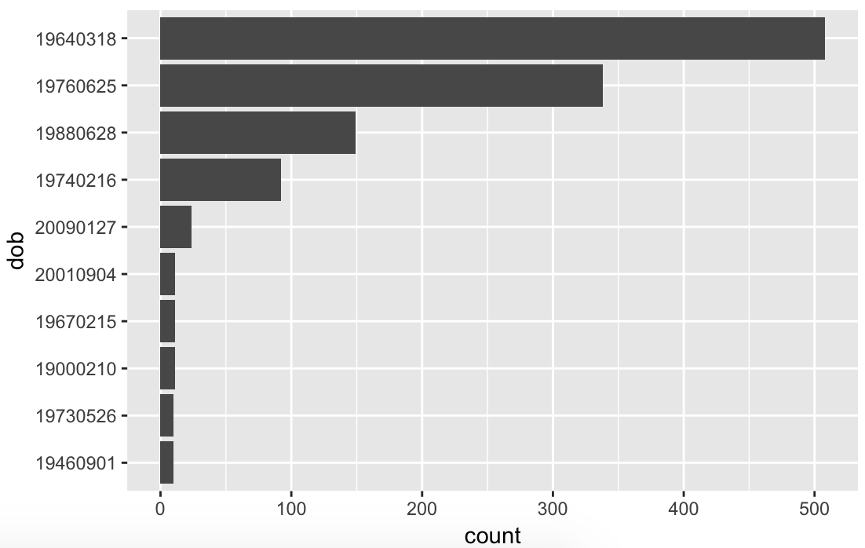

Field Name: homephone

Description:

“homephone” is a categorical variable that contains inputs from applicants of their home phone number.

Unique Values:

100 populated with 22,181 unique values from 100,000 records. No missing values. The most frequent home phone number “9105580920” appeared 7735 times, which accounts for 7.74% of all records. This homephone number is likely to be a frivolous value.

The top 10 most frequent records are listed below:

homephone | Frequency
9105580920 | 7.74%
6384782007 | 0.05%
2113738531 | 0.03%
6035129044 | 0.03%
4024680535 | 0.03%
9537440042 | 0.02%
8779246797 | 0.02%
161072500 | 0.02%
1992166532 | 0.02%
3968534400 | 0.02%

The distribution of the top 10 records (excluding the most frequent record “9105580920”):

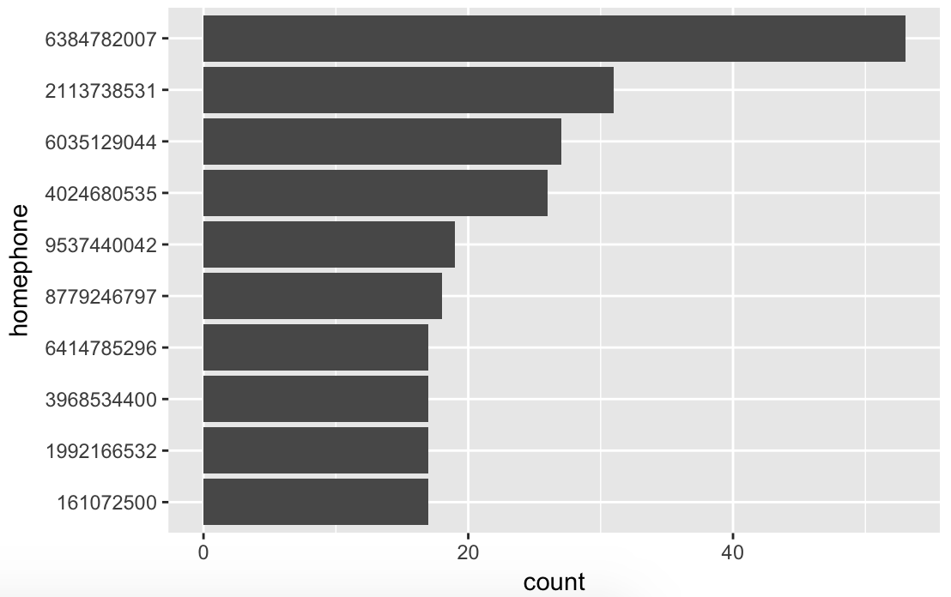

Variable Construction

To make the analysis more indepth and meaningful we modified some of the existing variables before we built our expert variables.

- We built a new variable “PERSON”, which is the concatenation of the existing variables “firstname”, “lastname” and “dob”.
- We built a new variable “ADD_ZIP”, which is the concatenation of the existing variables “address” and “zip5”.

Since this analysis involves time, we chose two different time windows, 3 days and 7 days. The rationale is to capture more fraudulent applications.

We then build two types of variables:
- Type I variables are the count of one entity associated with specific value of another entity in a particular time frame. The count of Type I variables is dependent on the time window and hence they are created separately for 3-day and 7-day time window.
Example: PERSON_SSN tells the number of PERSONs relate with one SSN.

- Type II variables are the count of an entity in a time frame. The count of Type II variables is also dependent on the time window and hence they are also created separately for 3-day and 7-day time window.
Example: TIME_PERSON tells the number of times a particular person (“PERSON”) appears in a 3-day time window or a 7-day time window.

Type I variables

There are a total of 12 Type I variables.

- PERSON_SSN: the number of people (“PERSON”) related with one particular ssn in a 3-day time window or a 7-day time window.

- PERSON_PHONE: the number of people (“PERSON”) related with one particular phone number in a 3-day time window or a 7-day time window.

- PERSON_ADD: the number of people (“PERSON”) related with one particular address and zip combination (“ADD_ZIP”) in a 3-day time window or a 7-day time window.

- SSN_PERSON: the number of ssns related with one particular person (“PERSON”) in a 3-day time window or a 7-day time window.

- SSN_PHONE: the number of ssns related with one particular phone number in a 3-day time window or a 7-day time window.

- SSN_ADD: the number of ssns related with one particular address and zip combination (“ADD_ZIP”) in a 3-day time window or a 7-day time window.

- PHONE_PERSON: the number of phone numbers related with one particular person (“PERSON”) in a 3-day time window or a 7-day time window.

- PHONE_SSN: the number of phone numbers related with one particular ssn in a 3-day time window or a 7-day time window.

- PHONE_ADD: the number of phone numbers related with one particular address and zip combination (“ADD_ZIP”) in a 3-day time window or a 7-day time window.

- ADD_PERSON: the number of address and zip combination (“ADD_ZIP”) related with one particular person (“PERSON”) in a 3-day time window or a 7-day time window.

- ADD_SSN: the number of address and zip combination (“ADD_ZIP”) related with one particular ssn in a 3-day time window or a 7-day time window.

- ADD_PHONE: the number of address and zip combination (“ADD_ZIP”) related with one particular phone number in a 3-day time window or a 7-day time window.

Type II variables

There are a total of 4 Type II variables.

- TIME_PERSON: the number of times a particular person (“PERSON”) appears in a 3-day time window or a 7-day time window.

- TIME_SSN: the number of times a particular ssn appears in a 3-day time window or a 7-day time window.

- TIME_PHONE: the number of times a particular phone number appears in a 3-day time window or a 7-day time window.

- TIME_ADD_ZIP: the number of times a particular address and zip combination (“ADD_ZIP”) appears in a 3-day time window or a 7-day time window.

We wrote for loops in R to count the number of times a variable appeared in a time window and wrote functions to repeat the process for all the expert variables.

Handling Frivolous values

The expert variables related to “ssn”, “homephone”, and “ZIP_ADD” were affected by the appearance of frivolous values. The frivolous value in “dob” did not affect our analysis because we built a variable “PERSON” instead of “dob” for identification of an applicant. In this light, “PERSON” will not be frivolous anymore though it contains frivolous ‘dob’.

Corrective Action: To eliminate the effects posed by frivolous values, we replaced the affected records in the expert variable with the mean of all the records (excepting records affected by frivolous values) in that specific expert variable.

Fraud Algorithm

Principal Component Analysis (PCA)

After creating expert variables, we did standardization and dimensionality reduction. To do this, we ran the PCA algorithm for both 3-day time window and 7-day time window.

We performed principal components analysis using the prcomp() function, which was one of several functions in R that perform PCA. By default, the prcomp() function centers the variables to have mean zero. By using the option scale = TRUE, we scaled the variables to have standard deviation of 1. The ‘center’ and ‘scale’ components correspond to the means and standard deviations of the variables that were used for standardization prior to implementing PCA. Additionally, this z scaling made all these variables associated with frivilous values into the value zero.

The rotation matrix provided the principal component loadings, each column of pr.out$rotation contained the corresponding principal component loading vector.

To compute the proportion of variance explained by each principal component, we divided the variance explained by each PC by the total variance explained by all 16 PCs. We made the scree plot and cumulative plot to determine which PCs to keep. We would like to use the smallest number of PCs required to get a good understanding of the data. For the 3-day time window analysis, we discovered that there is a significant drop(‘elbow’) between PC6 and PC7 according to the scree plot. Thus, we decided to keep PC1 through PC6, which explained approximately 99% of the entire dataset. For the 7-day time window analysis, by examining the scree plot below, we discovered that it has similar trend with 3-day time window, indicating a significant drop(‘elbow’) between PC6 and PC7. Thus, we decided to keep PC1 through PC6, accounting for approximately 99% of the entire dataset.

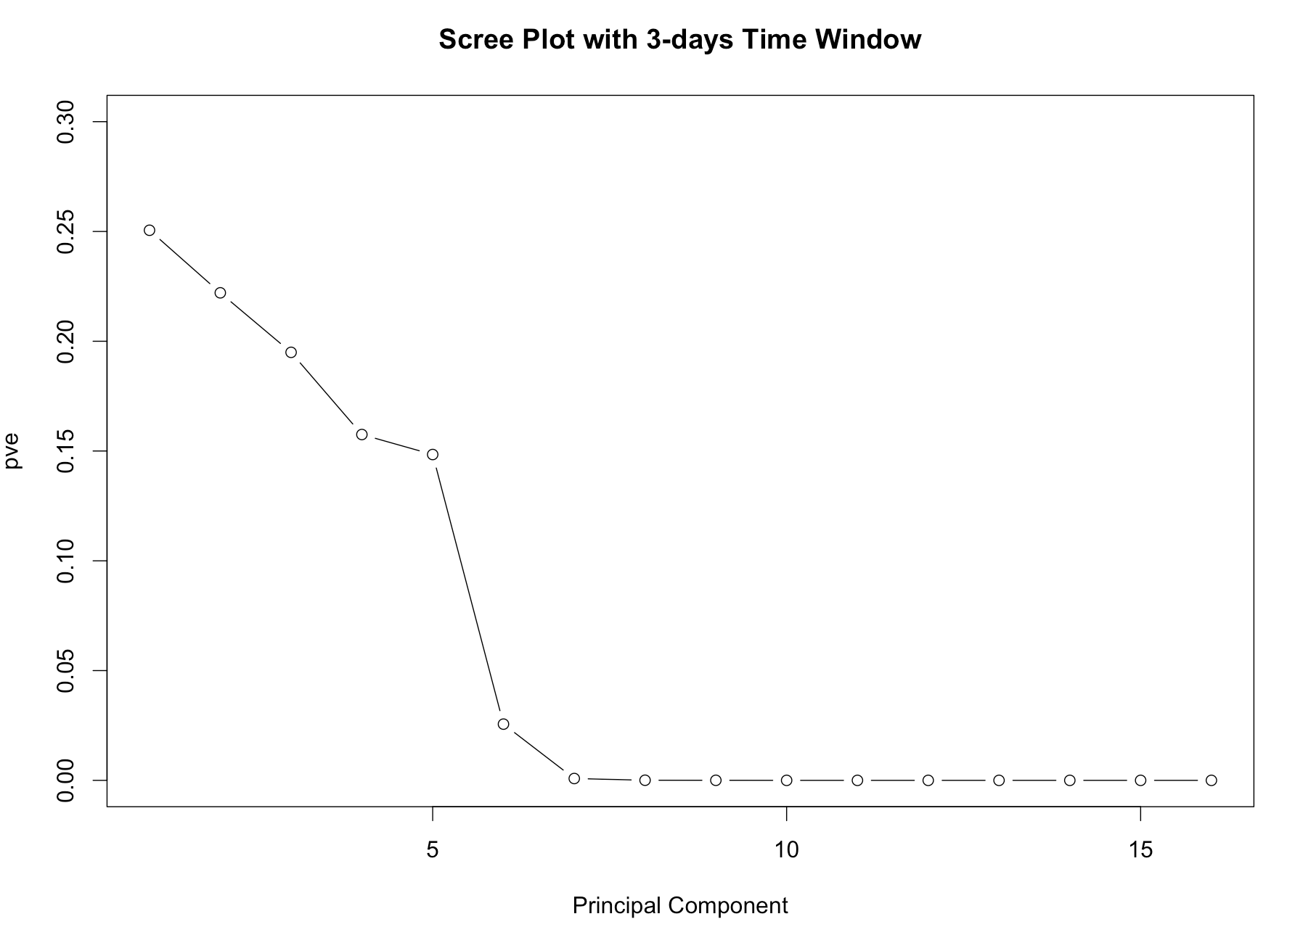
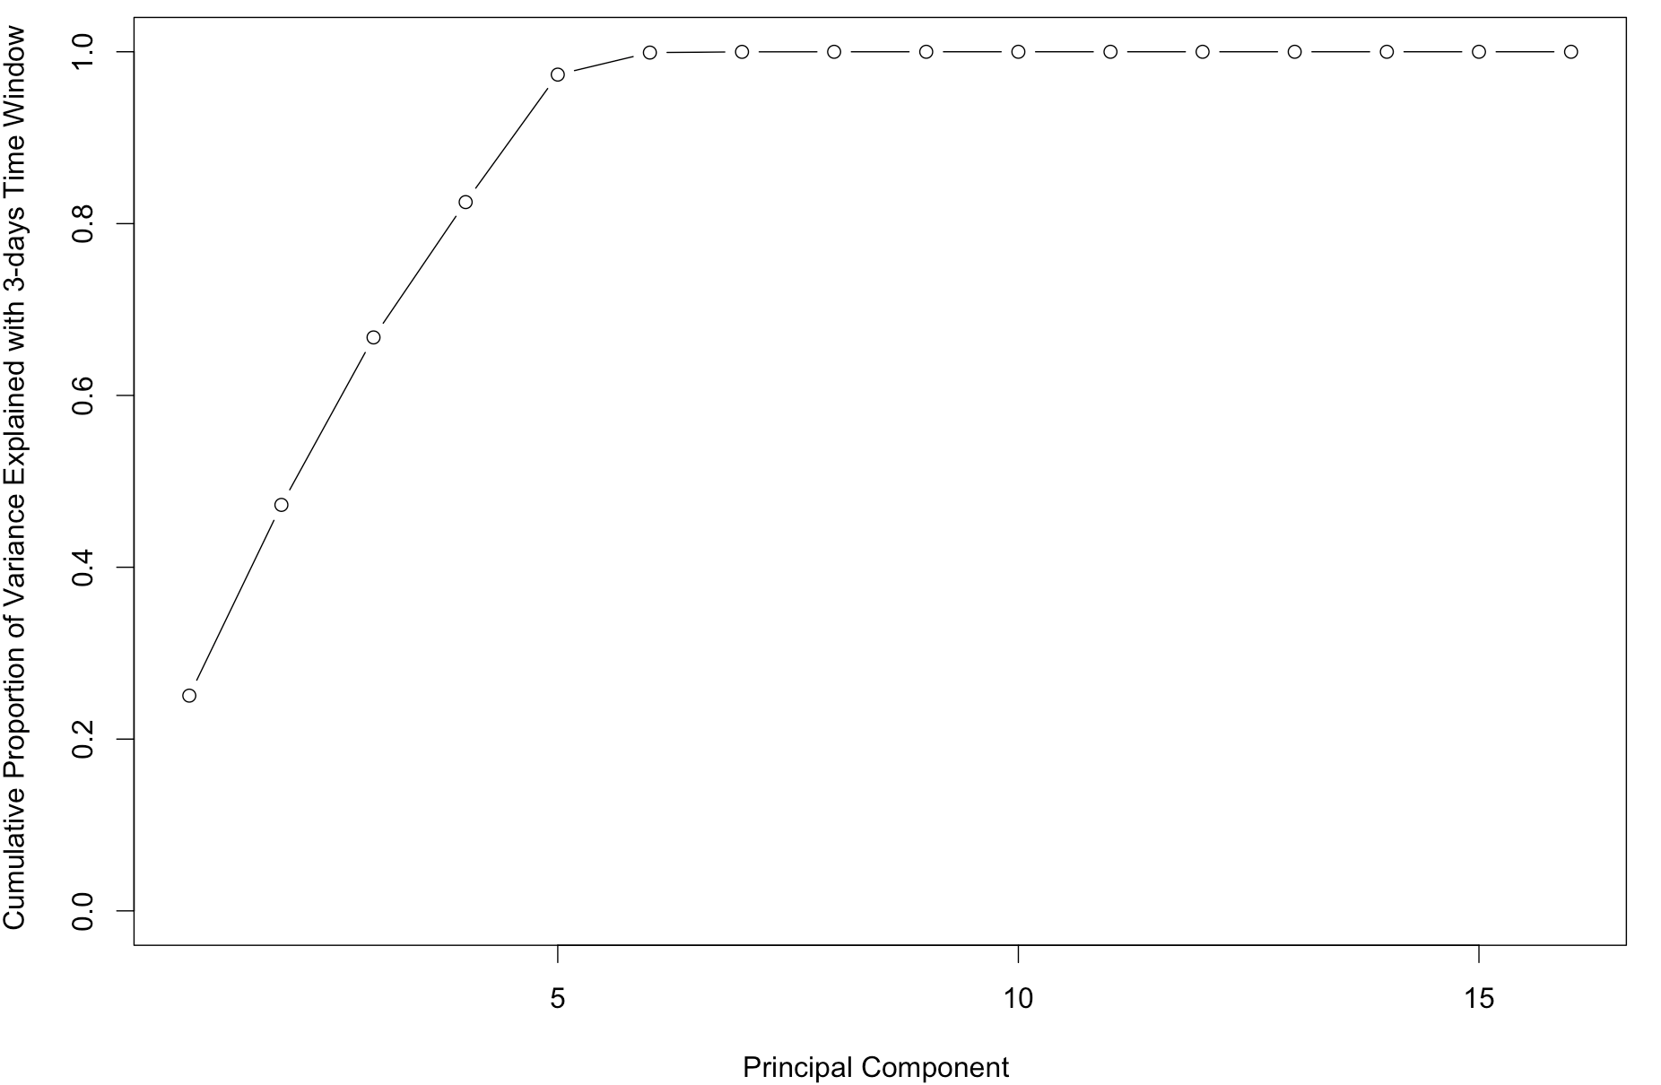

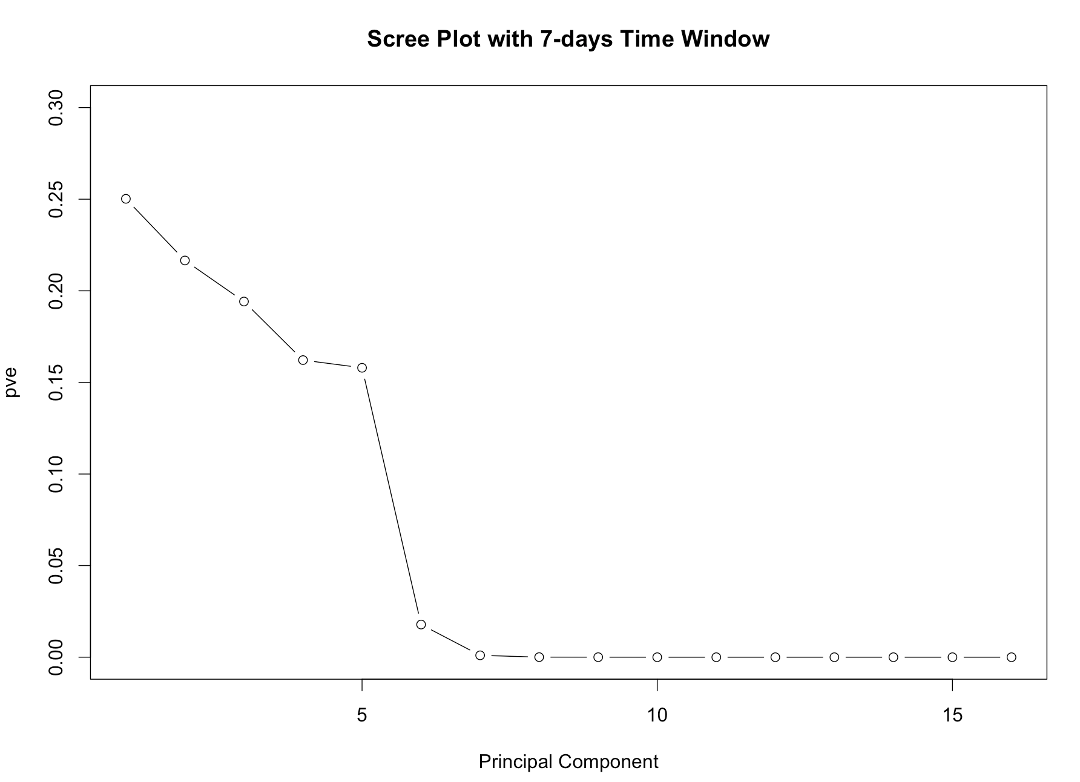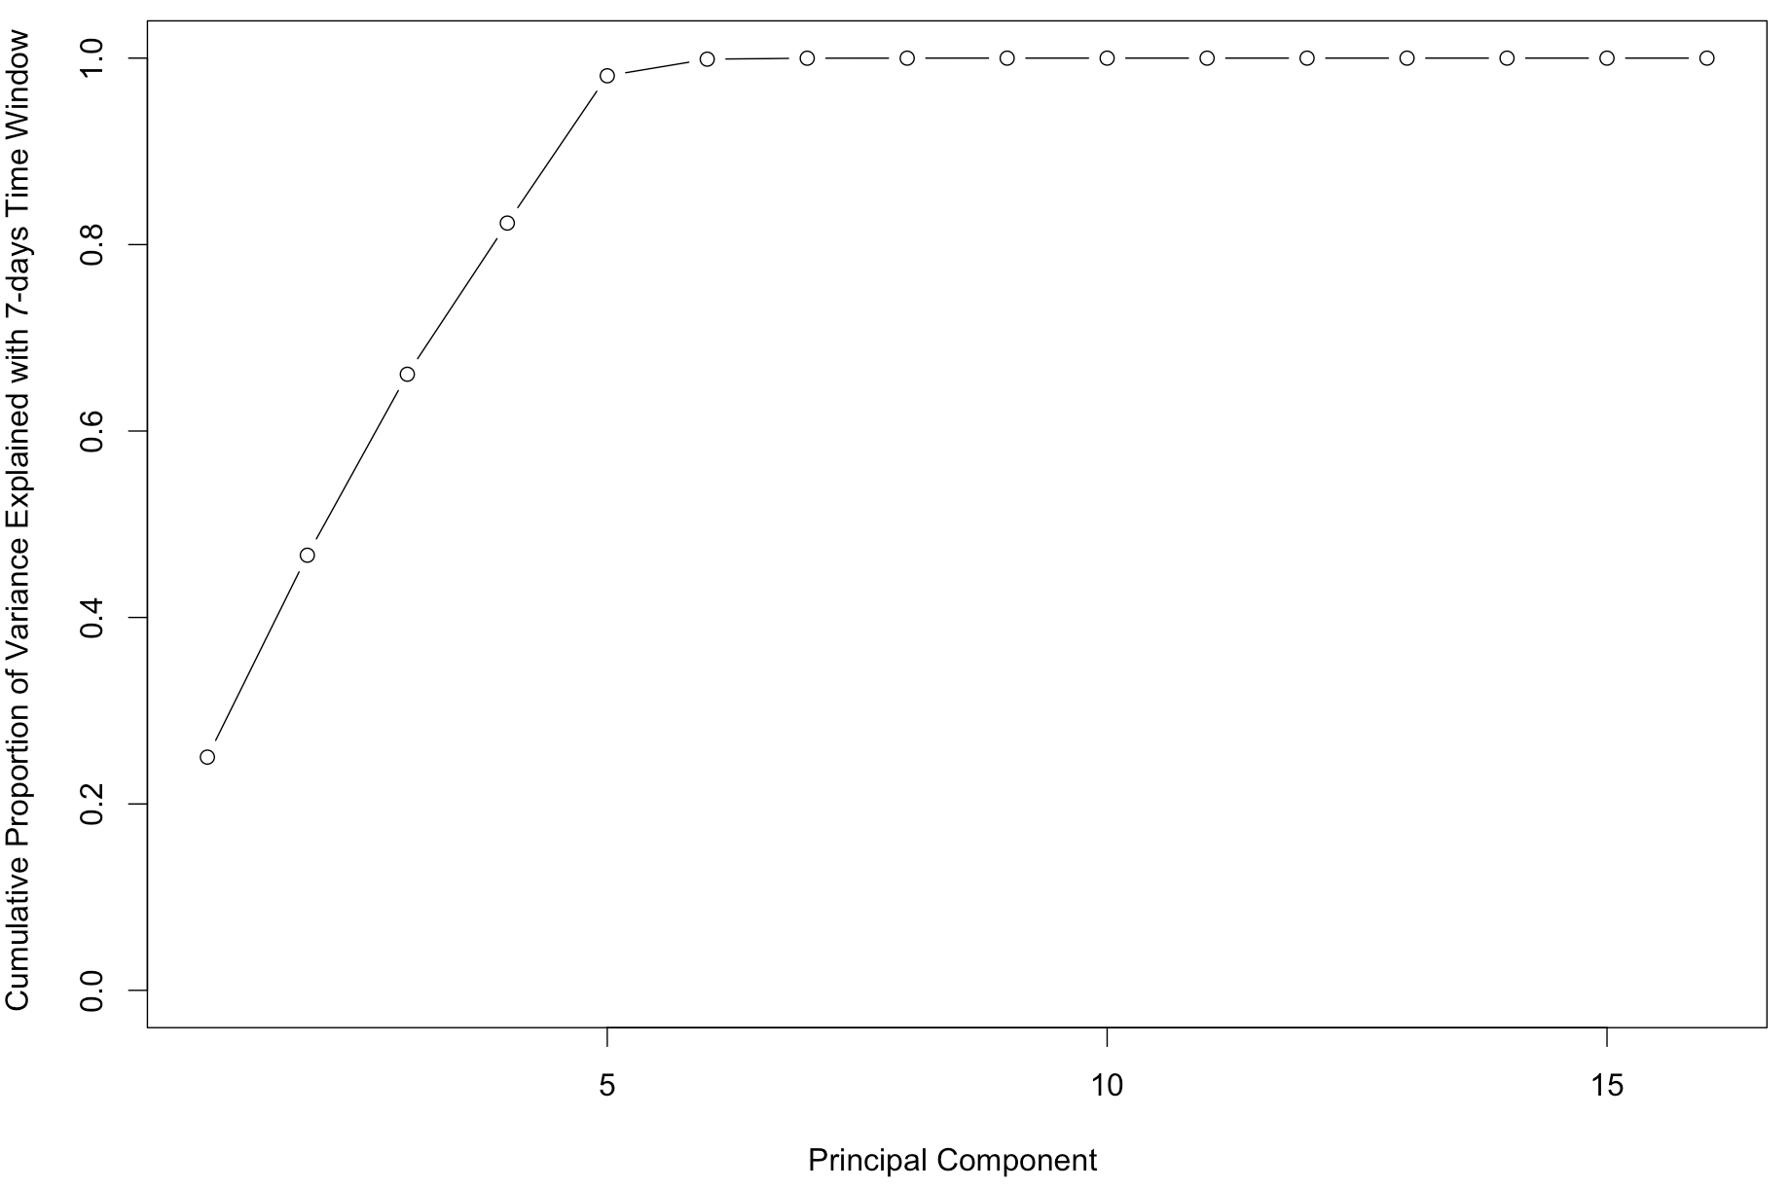

Calculation of fraud scores

Autoencoder

First we tried auto-encoding our PCs using an R package called “h2o”. Then, we called the deep learning function with parameter “autoencoder” set to TRUE. This function took the original dataset with all the PCs and auto-encoded it. The network in our algorithm contain 4 hidden layers with 100 neurons in each hidden layer. We then called the h2o.anomaly function to reconstruct the original dataset using the reduced set of features and calculated a mean squared error between both. We set the “per_feature” parameter to TRUE because we want a reconstruction mean error based on individual features. We saved the reconstruction error in a dataset called “error”. From plotting of the “error” dataset, we could see that there are some abnormal values, which might indicate fraud.

In the end we summed the reconstruction error values of all the PCs to get a single score, which will be our fraud score from autoencoder, for each of the record. Also, we repeated the process twice for both 3-day time window and 7-day time window.

Heuristic Algorithm

Another way to calculate the fraud score was by heuristic algorithm. Our way was calculating the mahalanobis distance between each record and the (mean,covariance) of records within each particular PC. The mahalanobis distance was our fraud score for each record. It was calculated using the function ‘mahalanobis’ in R. Again, we ran the algorithm for both 3-day time window and 7-day time window.

Results

We sorted the records according to fraud scores from both autoencoder and heuristic algorithm outcomes. The majority of records had low fraud scores while a small proportion of the records had typically high fraud scores.

Below is an overview of what the distribution of fraud scores look like from both methods and both time windows:
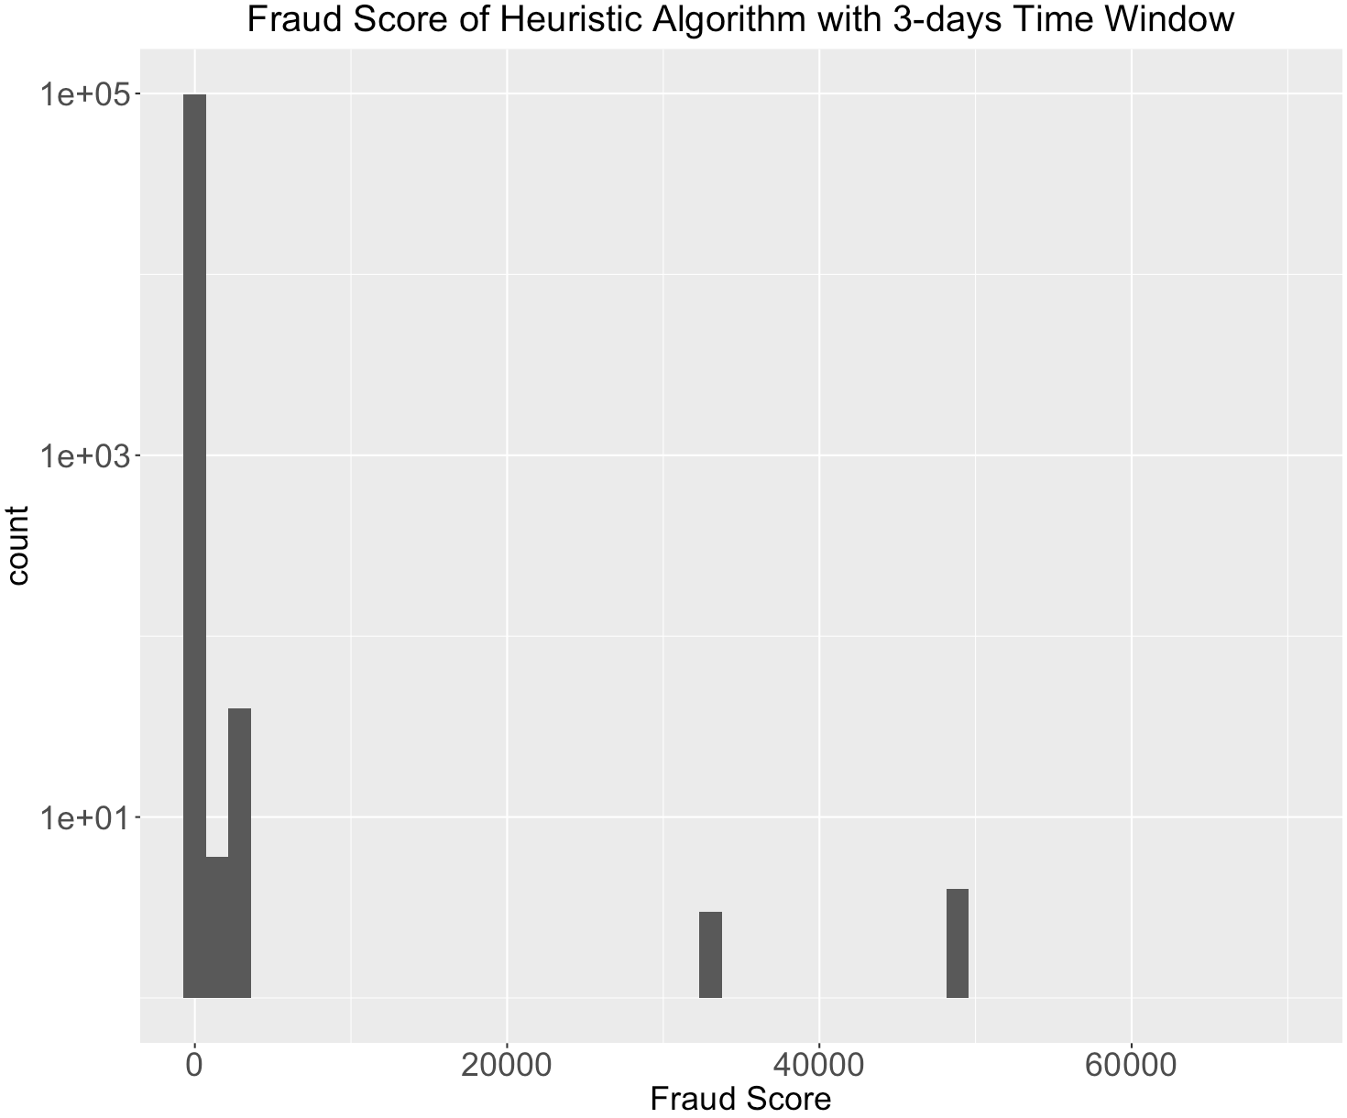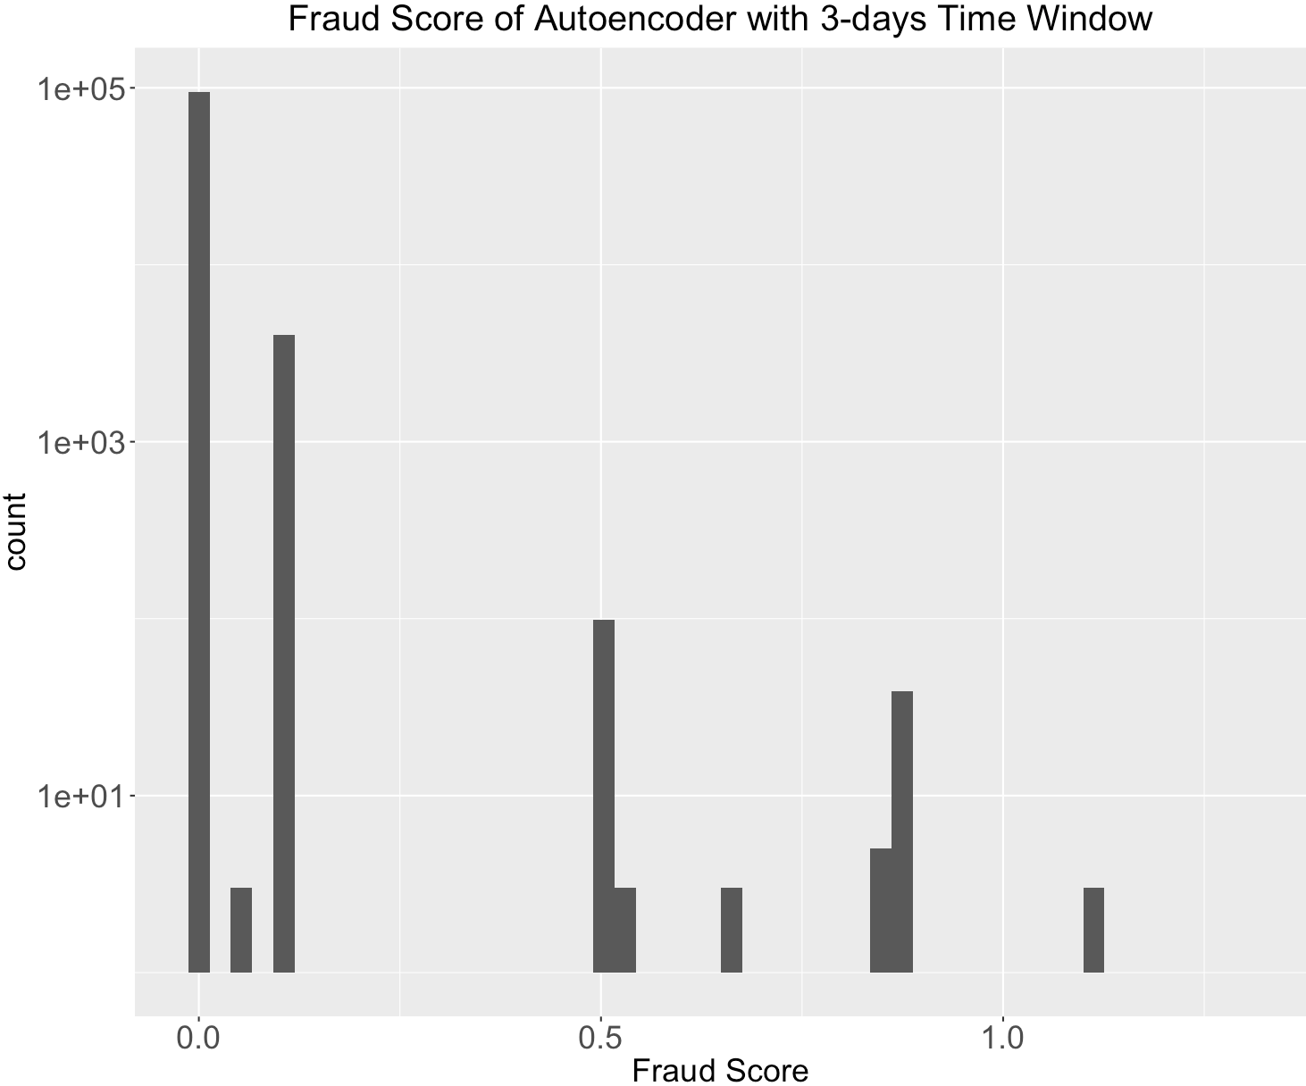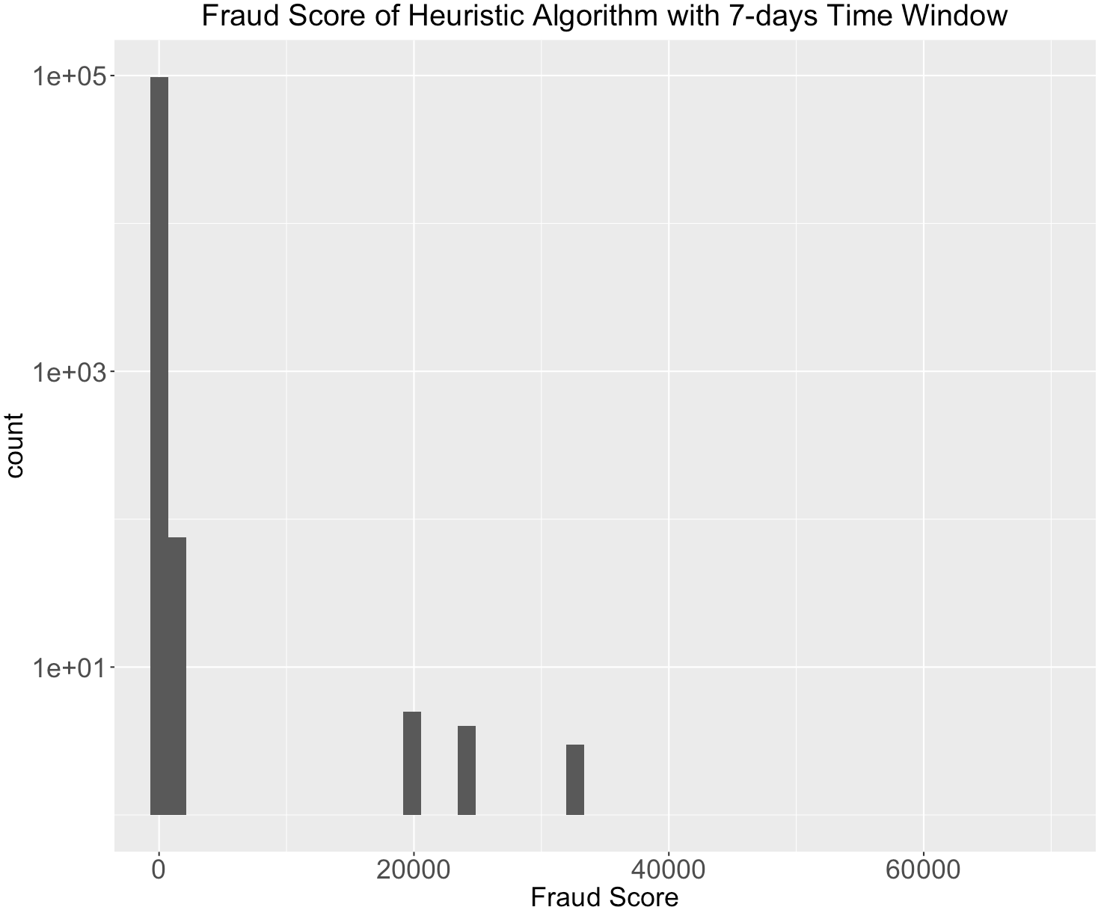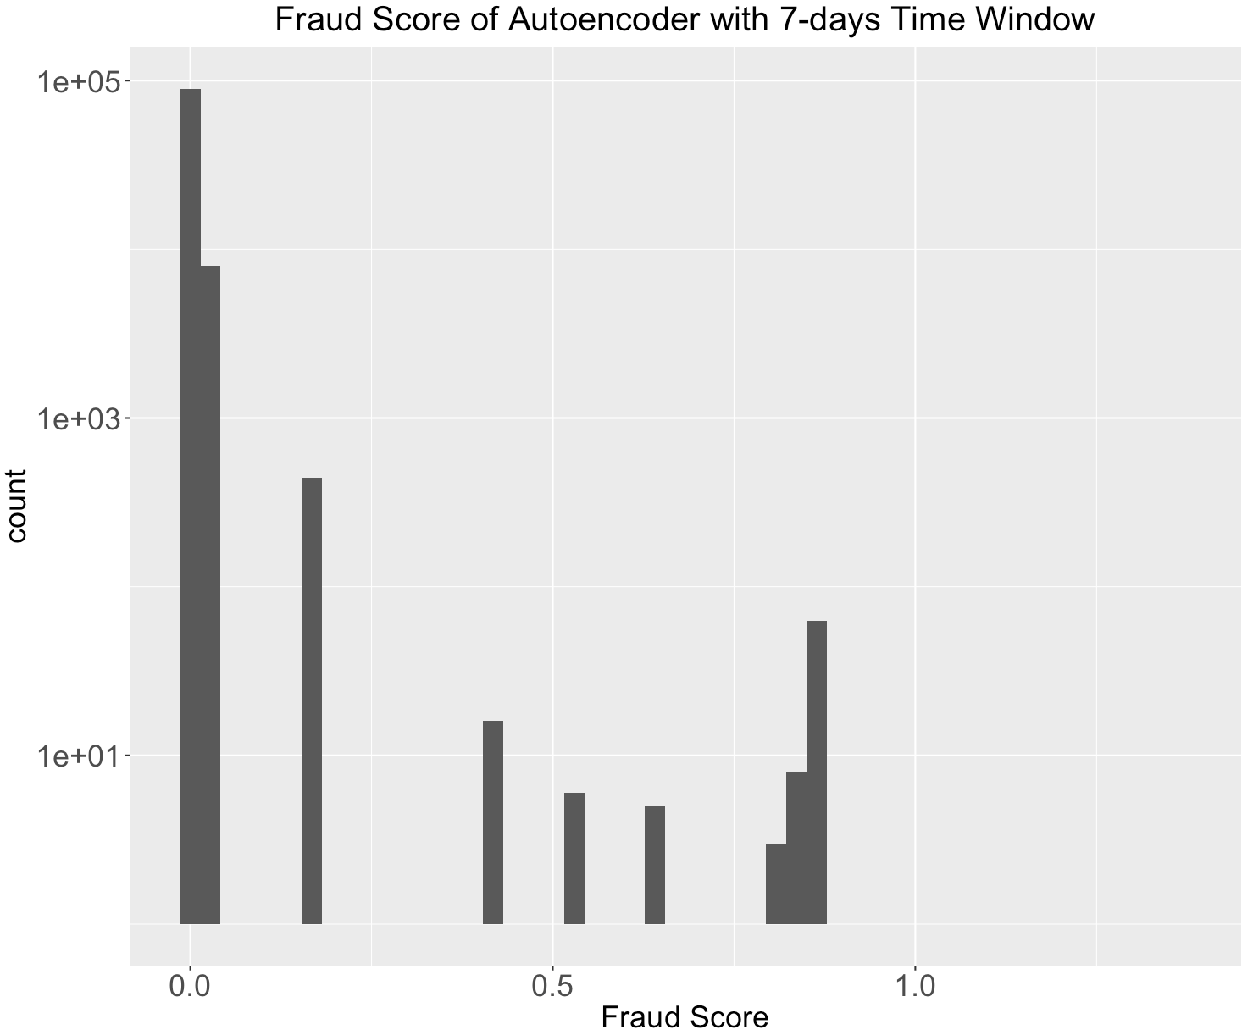

All the fraud score distribution appeared kind of discrete with several small peaks. This was due to the fact that all the expert variables we created were counts in nature, which were discrete and only took integers from 1 to 10. Also, many records had identical values, since their values of expert variables were simply “1 1 1 1 1 …”. Therefore, after the standardization and PCA algorithm, these records still took the same value.

We decided to look at the overlapping part of the top 1% high score records from autoencoder output and the top 1% high score records from heuristic algorithm output. For both 3-days time window outputs and 7-days time window outputs, almost 100% of the records from the two algorithms match. This could also be explained by the above distribution plot -- a certain small group of the records were highly suspicious and got high scores.

Insights

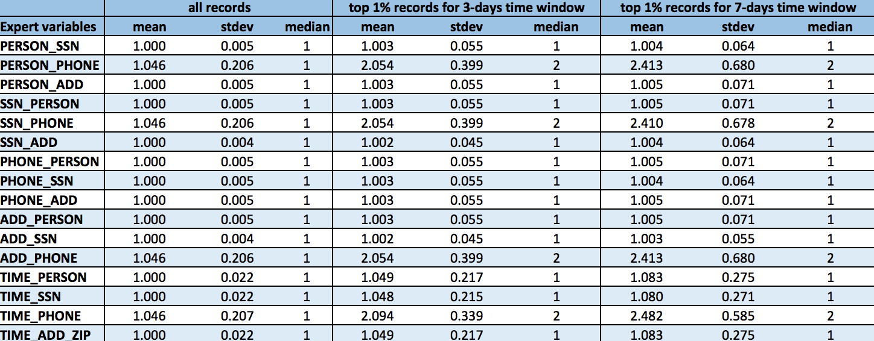

In the above summary descriptive data table, we compared the mean, standard deviation and median among the whole dataset, top 1% high-scoring records with 3-days time window, and top 1% high-scoring records with 7-days time window. We can see that there are obvious difference between the whole dataset and the top 1% records. Typically, top 1% records have higher average values for all the expert variables we created. Besides, the average values of expert variables with 3-day time window is always lower than those with 7-days time window. This is very reasonable since with 7-days time window, we can always accumulate more counts for any expert variable.

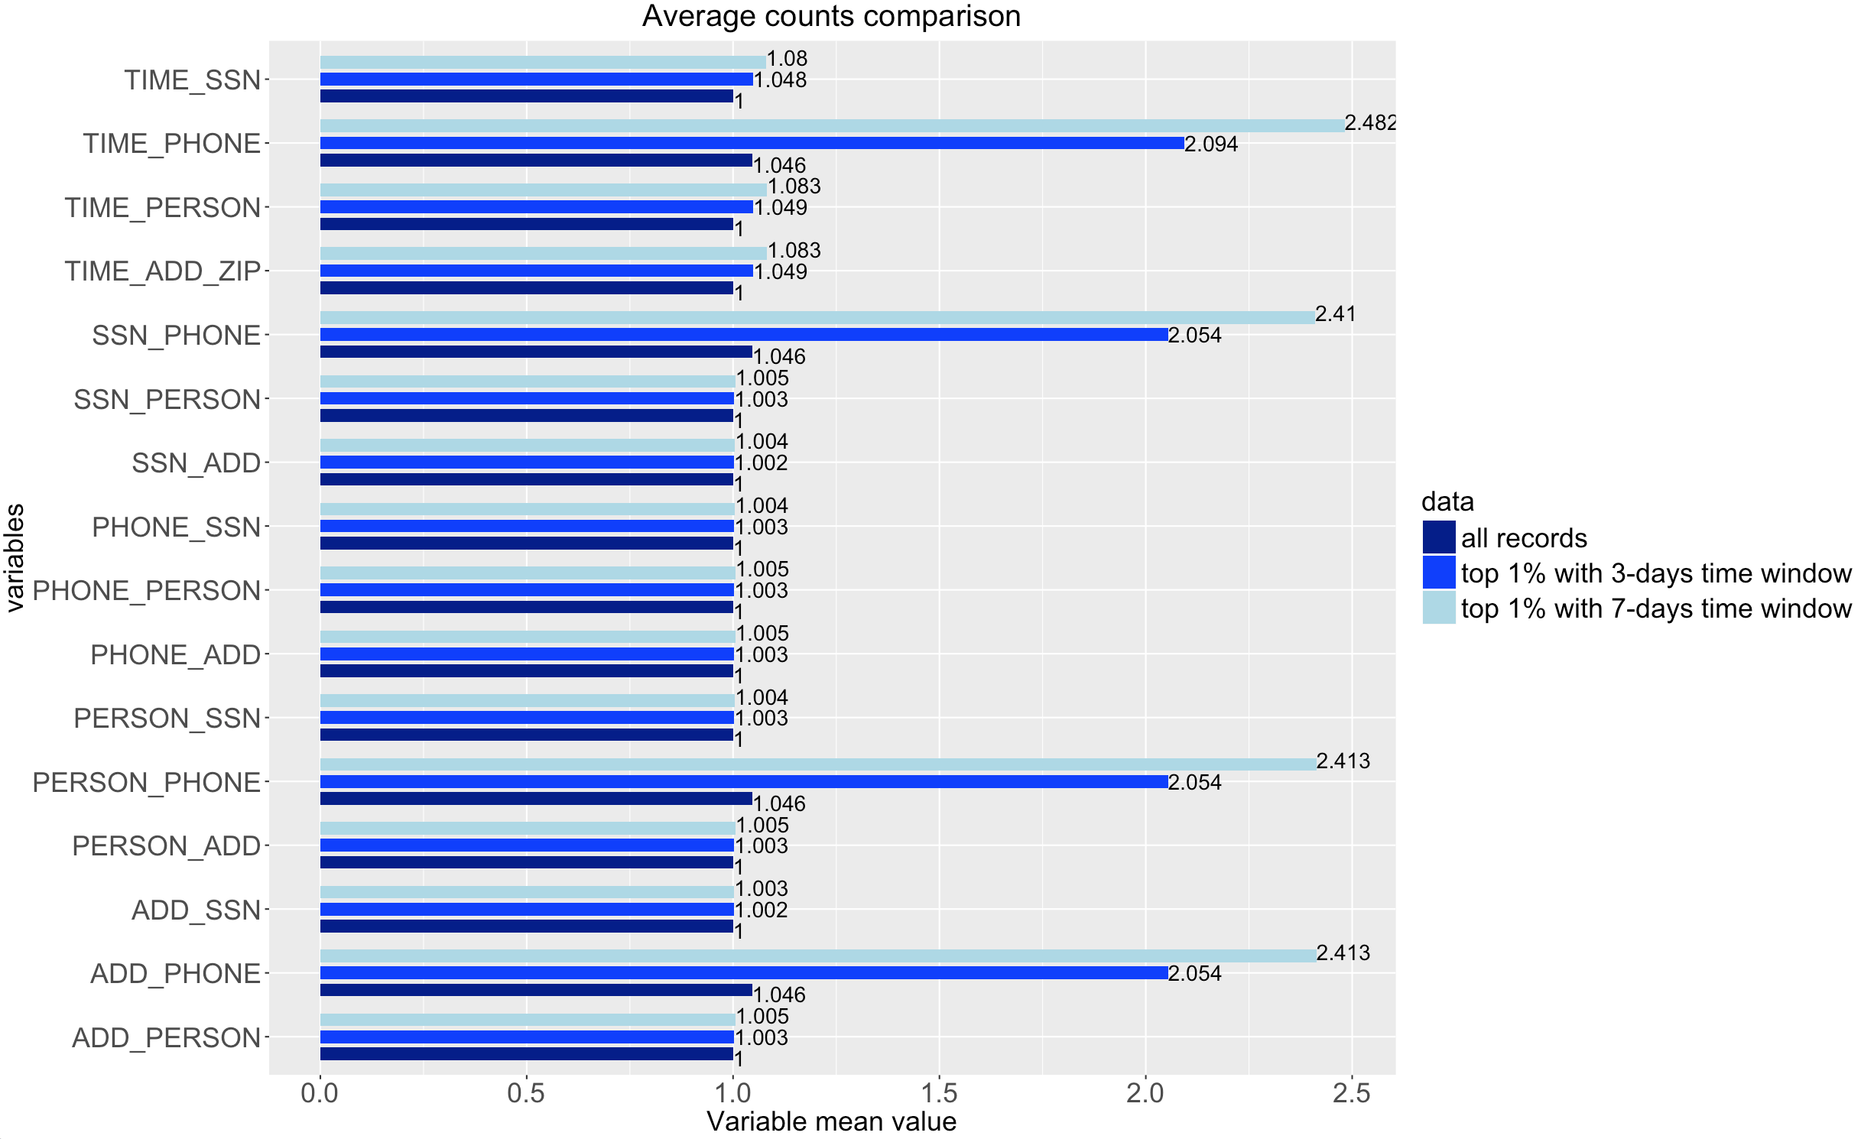

When we take a closer look at all the mean values for different expert variables as plotted above, we can see that there are larger deviation between the whole dataset and the top records for four expert variables -- TIME_PHONE, SSN_PHONE, PERSON_PHONE and ADD_PHONE.

TIME_PHONE is the frequency a certain phone number appears within the time window, while the other three represent the number of different SSN number, or personal information or address information associated with a certain phone number. Therefore, a single phone number is used multiple times with different inputs in other fields while making applications. We come up with two explanations for this pattern. The first explanation is, although people could use fake information to apply for a product, they still need a correct phone number to get contacted for the application results, so some people just make multiple trials with different SSN, address or name, but using his real phone number. The second explanation is, the members of some illegal groups just share a single phone number to make fraudulent applications.

In-depth analysis of Top 10 records

The below table shows the top 10 records for both time windows and their application information. There are four records (record # in red) appearing in both top10 lists, indicating high probability to be fraudulent. Besides, when we look at the application information, we can see few records with frivolous values are included. This is because before we calculated the fraud scores, we had replaced all the values involving frivolous values with the average of other records without frivolous values.

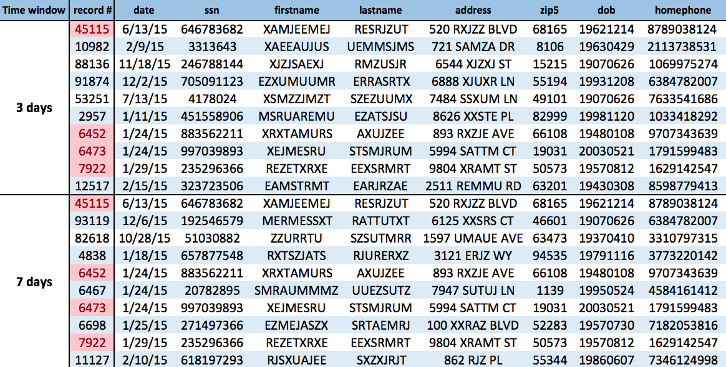

Then we looked at the value of expert variables of each of these top records in the following table. We can see there are lots of expert variables with values greater than 1.

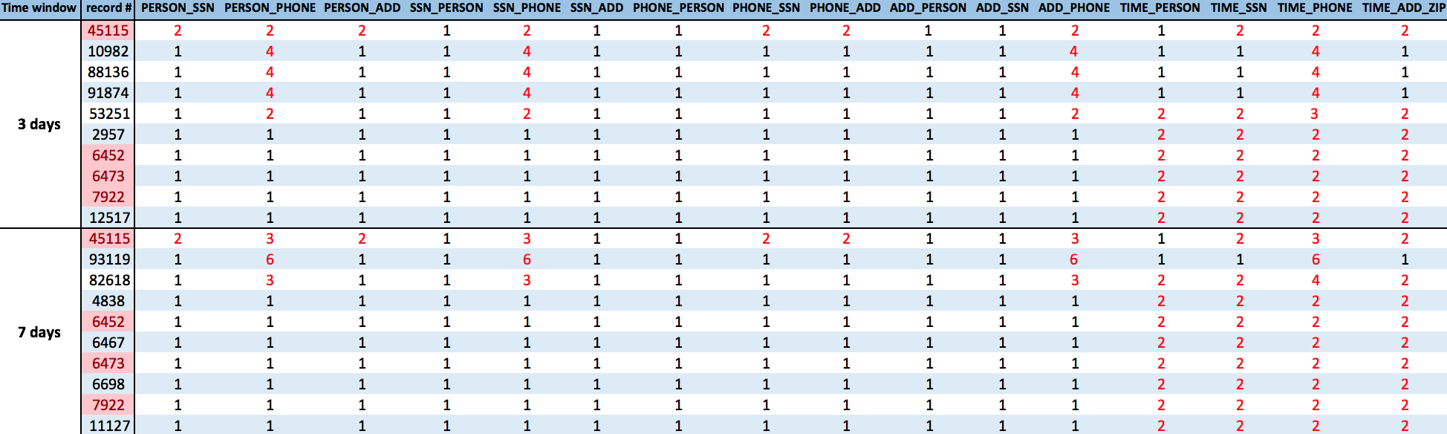

We also examined them one by one:

- Record number 45115
The SSN of this application has been used twice with different personal information in past 3 or 7 days, and the phone number and address also have this pattern. This record is highly likely to be fraudulent, as someone fraudulently applying for products with different combination of real and fake information.

- Record number 10982
The phone number in this application record has been used 4 times with different personal information, SSN and address. This could be caused by an illegal group of 4 sharing the same phone number, or someone trying to make application with his real phone number and different sets of fake information.

- Record number 88136
Just like in record number 10982, the phone number in this application record has been used 4 times with different personal information, SSN and address. This could be caused by an illegal group of 4 sharing the same phone number, or someone trying to make application with his real phone number and different sets of fake information.

- Record number 91784
Just like in record number 10982 and 88136, the phone number in this application record has been used 4 times with different personal information, SSN and address. This could be caused by an illegal group of 4 sharing the same phone number, or someone trying to make application with his real phone number and different sets of fake information.
The three phone numbers in record 10982, 88136 and 91784 are very likely to be related to fraud in applications.

- Record number 53251
The phone number in this record has been associated with two different people, SSN and address in past 3 days. Meanwhile, the personal information, SSN and address has also been seen twice in the past three days. This record is highly likely to be fraudulent, as someone fraudulently applying for products with different combination of real and fake information.

- Record number 2957, 6452, 6473, 7922, 12517
In each of these five records, The person used the same set of information (name, date of birth, SSN, phone number, address and zipcode) applied twice in past three days. This may not be a signal of fraud. Maybe he or she just didn’t receive the application results and decided to apply again the next day. Or it could be due to Internet connection error.

- Record number 93119
The phone number in this application record has been associated with six different people and SSN in the past seven days. However, meanwhile, it has only one address associated with it. This could be caused by a group of 6 (maybe a family or roommates) sharing the same home phone number, or someone trying to make application with his real phone number and different sets of fake information. Therefore, this record is very likely to be fraudulent.

- Record number 82618
The phone number in this application record has been associated with three different people and SSN in the past seven days. However, it has only one address associated with it. Meanwhile, the person, SSN and address information have all appeared twice in the past seven days, and the phone number has appeared four times. This is very likely to be caused by someone applying multiple times with different sets of fake information. Therefore, this record is highly likely to be fraudulent.

- Record number 4838, 6467, 6698, 11127
In each of these four records, The person used the same set of information (name, date of birth, SSN, phone number, address and zipcode) applied twice in past seven days. This may not be a signal of fraud. Maybe he or she just didn’t receive the application results and decided to apply again a few days later. Or it could be due to Internet connection error.

Appendix

Data Quality Report

Summary

File Description:

Production Application Data is a dataset containing the records of 100,000 product applications. It includes information about the date the application made, and the SSN number, name, address, zip code, data of birth and home phone number that each applicant self-reported.

File Name:

Applications 100k.xlsx

Data Source:

This dataset is the simulated data based on real product application records.

Number of Records:

100,000 records

Number of Fields:

9 variables in total – 6 categorical variables, 1 text variable, 2 date variables

Field Name | Data Type
record | Categorical variable
date | Date variable
ssn | Categorical variable
firstname | Categorical variable
lastname | Categorical variable
address | Text variable
zip5 | Categorical variable
dob | Date variable
homephone | Categorical variable

Time of Records:

Jan 1st 2015 – Dec 31st 2015

Fields Explanation

Field 1

Field Name: record

Description:

“record” is a categorical variable. It works as the ordinal reference number for each application record.

Unique Values:

100% populated with 100,000 unique values, ranging from 1 to 100,000. No repeated values or missing values exist.

Field 2

Field Name: date

Description:

“date” is a date variable, indicating the date that the application was made.

Unique Values:

100% populated with 365 unique values, i.e. every day in year 2015. Plot the distribution of the months and dates as below, we can see that the two distributions follow the natural occurrence distribution.
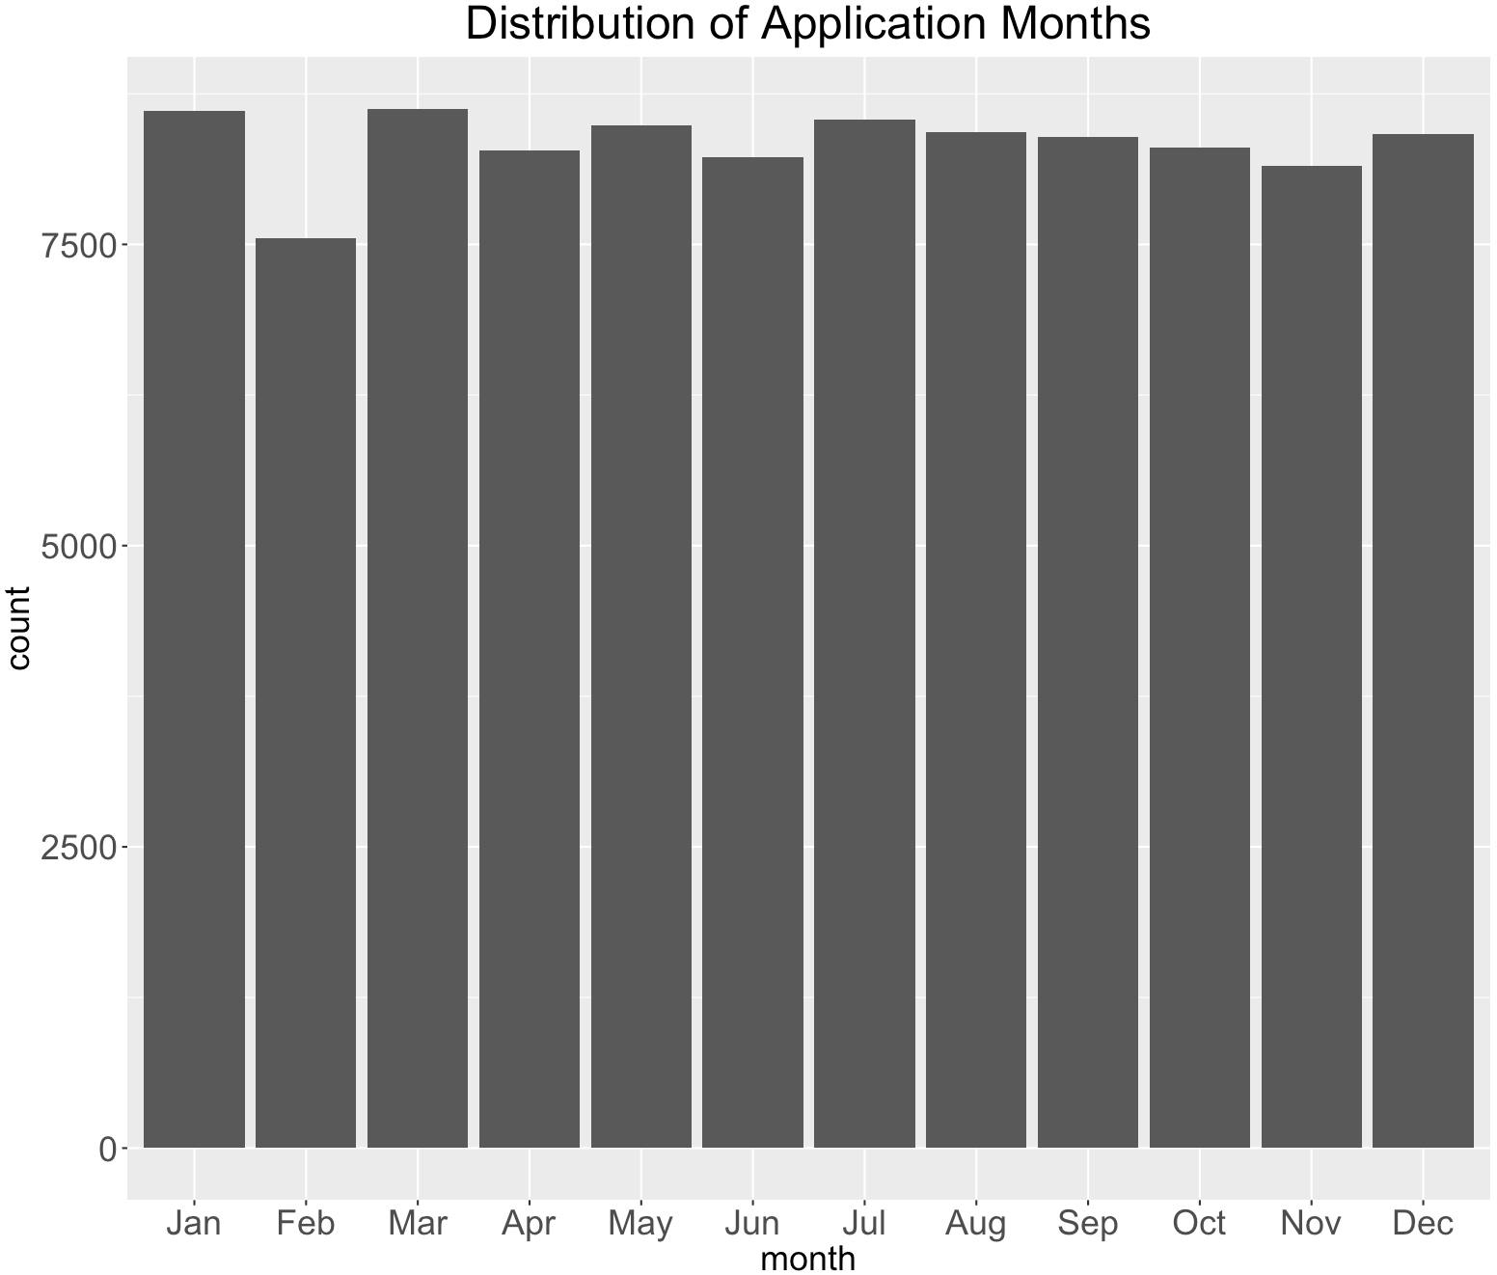

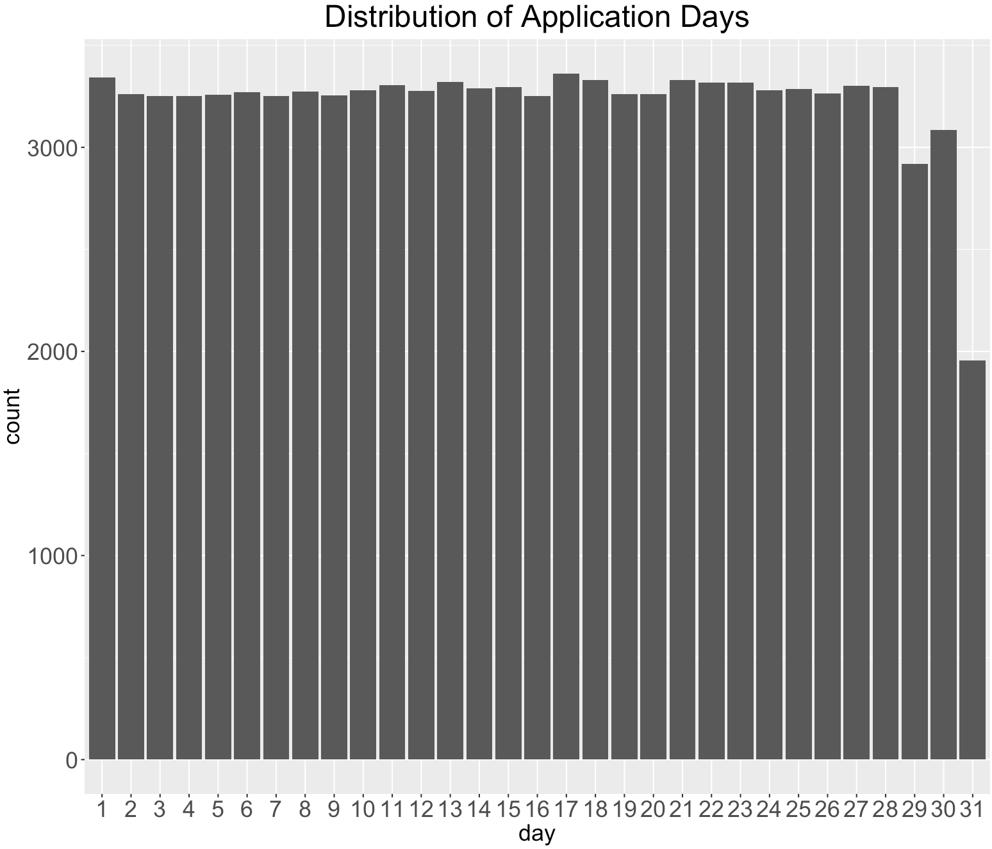
Field 3

Field Name: ssn

Description:

“ssn” is a categorical variable, indicating the applicant’s ssn number he or she self-reported.

Unique Values:

100% populated with 96,535 unique values. Values in this field have lengths from 4 to 9. A ssn shorter than 9 digits indicates there are leading 0s in the ssn record. For example, ssn record “2503” is actually “000002503”. The top 10 frequent appeared ssn records are shown below. It is obvious that the ssn record “737610282” is a frivolous record, which appears 173 times more than the second highest appeared record.

The top 10 most frequent records are listed below:

SSN | Frequency
737610282 | 1.73%
938972725 | 0.01%
810776805 | 0.01%
829352390 | 0.01%
473311863 | 0.00%
189622157 | 0.00%
163830210 | 0.00%
407447121 | 0.00%
118692079 | 0.00%
849295926 | 0.00%

The distribution of the top 10 records (excluding the most frequent record “737610282”):

Field 4

Field Name: firstname

Description:

“firstname” is a categorical variable, indicating the applicant’s first name he or she self-reported.

Unique Values:

100% populated with 16,576 unique values. The top 10 frequent appeared first name records are shown below.

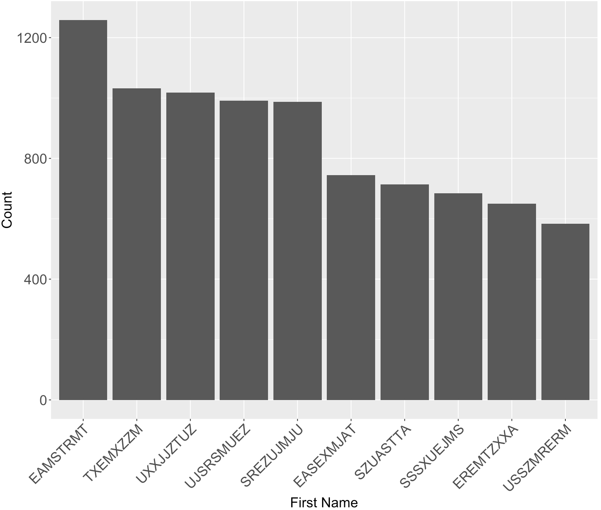
First Name | Frequency
EAMSTRMT | 1.26%
TXEMXZZM | 1.03%
UXXJJZTUZ | 1.02%
UJSRSMUEZ | 1.00%
SREZUJMJU | 1.00%
EASEXMJAT | 0.08%
SZUASTTA | 0.07%
SSSXUEJMS | 0.07%
EREMTZXXA | 0.07%
USSZMRERM | 0.06%

Field 5

Field Name: lastname

Description:

“lastname” is a categorical variable, indicating the applicant’s last name he or she self-reported.

Unique Values:

100% populated with 36,312 unique values. The top 10 frequent appeared last name records are shown below.

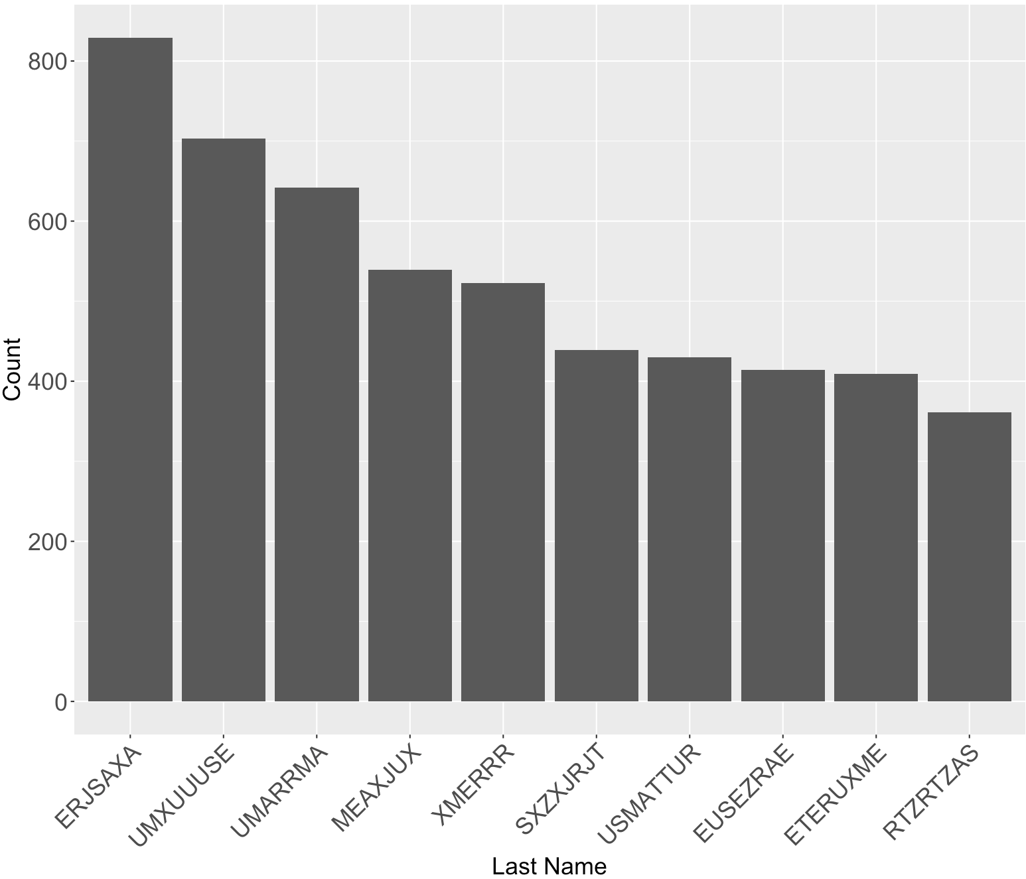
Last Name | Frequency
ERJSAXA | 0.83%
UMXUUUSE | 0.70%
UMARRMA | 0.64%
MEAXJUX | 0.54%
XMERRR | 0.52%
SXZXJRJT | 0.44%
USMATTUR | 0.43%
EUSEZRAE | 0.41%
ETERUXME | 0.41%
RTZRTZAS | 0.36%

Field 6

Field Name: address

Description:

“address” is a text variable that contains inputs from applicants of their address.

Unique Values:

100% populated with 97,563 unique values from 100,000 records. The most frequent address “2602 AJTJ AVE” appeared 117 times, which accounts for 0.12% of all records. This address is likely to be a frivolous address.

The top 10 most frequent records are listed below:

Address | Frequency
2602 AJTJ AVE | 0.12%
7433 RAEZA ST | 0.01%
1775 XJXE LN | 0.01%
426 XUAXZ BLVD | 0.01%
8911 MZSU DR | 0.01%
4907 RRAAU DR | 0.01%
606 EZZAU WY | 0.01%
4239 UEXRU BLVD | 0.01%
9566 RSSU WY | 0.01%
9777 RMJJU WY | 0.01%

The distribution of the top 10 records (excluding the most frequent record “2602 AJTJ AVE”):

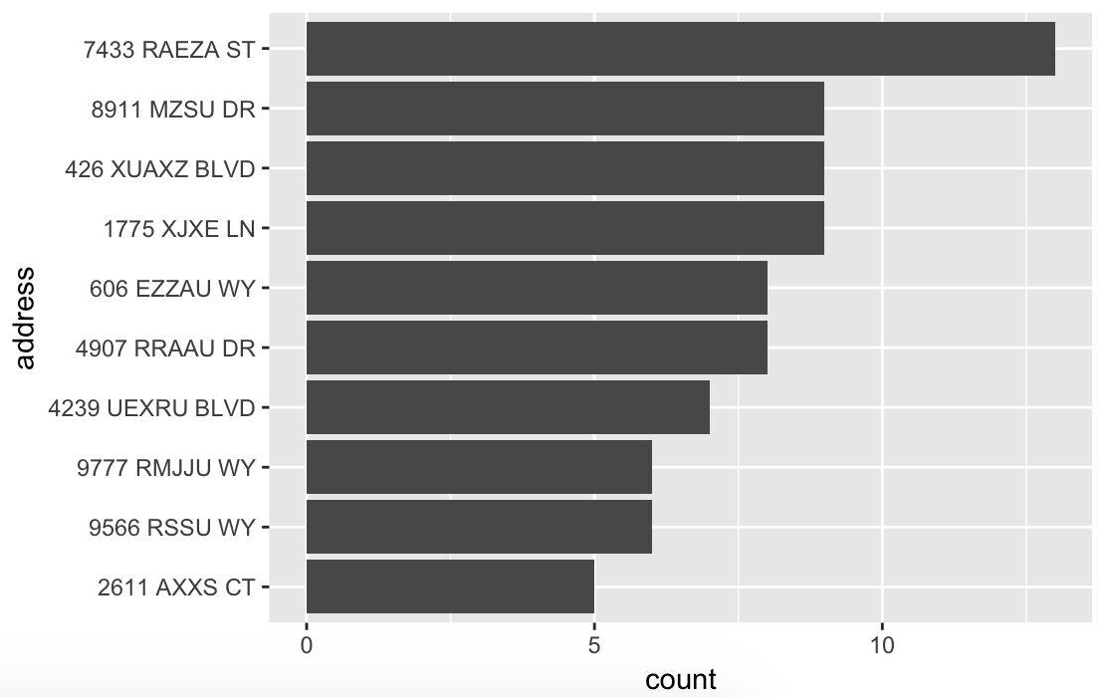

Field 7

Field Name: zip5

Description:

“zip5” is a categorical variable that contains inputs from applicants of their zip codes.

Unique Values:

100% populated with 16,547 unique values from 100,000 records. No missing values. The most frequent zip code “68138” appeared 823 times, which accounts for 0.09% of all records.

The top 10 most frequent records are listed below:

Zip5 | Frequency
68138 | 0.09%
89835 | 0.06%
14931 | 0.05%
94992 | 0.05%
90042 | 0.05%
49129 | 0.05%
35227 | 0.05%
59695 | 0.05%
64597 | 0.05%
14455 | 0.05%

The distribution of the top 10 records:

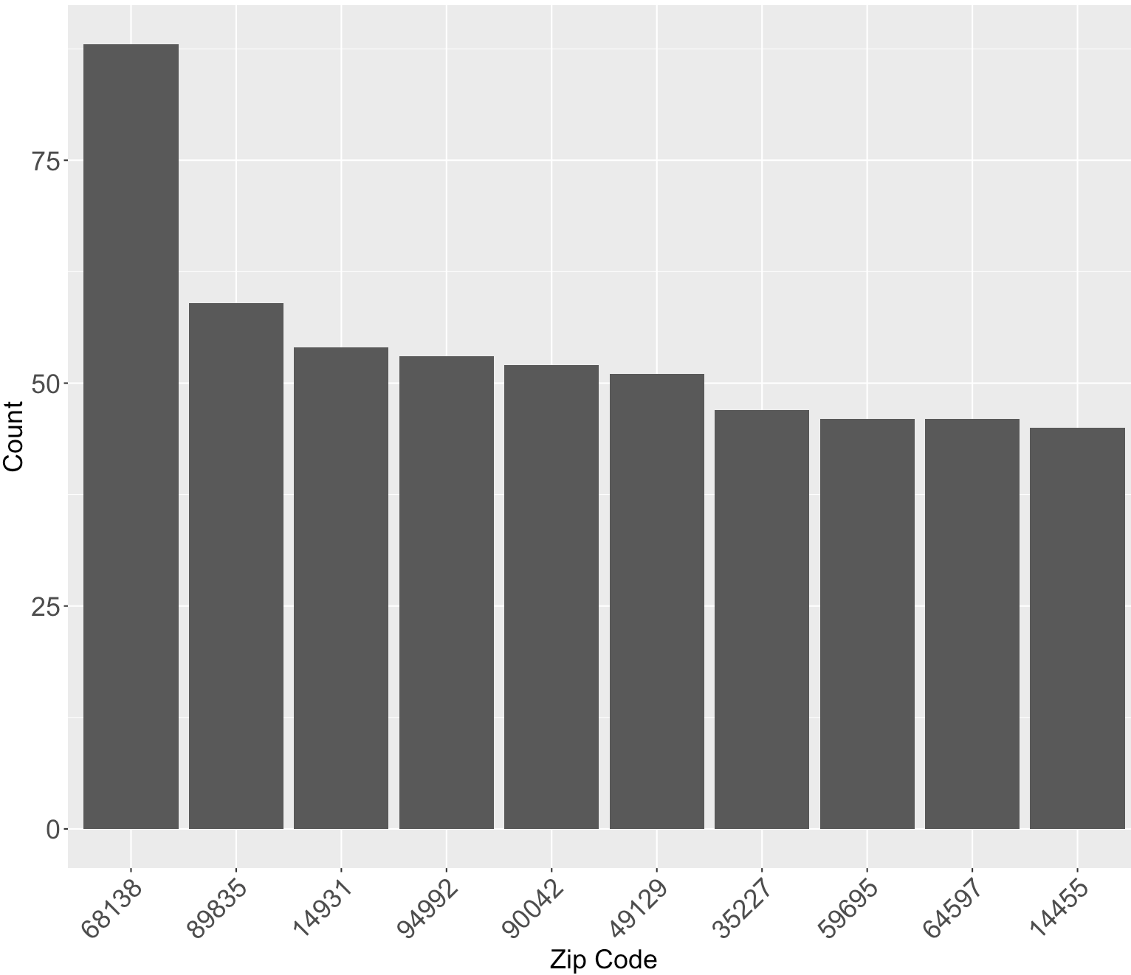

Field 8

Field Name: dob

Description:

“dob” is a date variable that contains inputs from applicants of their date of birth.

Unique Values:

100% populated with 36,816 unique values from 100,000 records. No missing values. The most frequent date of birth “19070626” appeared 12,488 times, which accounts for 12.49% of all records. This date of birth is likely to be a frivolous value.

The top 10 most frequent records are listed below:

dob | Frequency
19070626 | 12.49%
19640318 | 0.51%
19760625 | 0.34%
19880628 | 0.15%
19740216 | 0.09%
20090127 | 0.02%
19000210 | 0.01%
19670215 | 0.01%
20010904 | 0.01%
19460901 | 0.01%

The distribution of the top 10 records (excluding the most frequent record “19070626”):

Field 9

Field Name: homephone

Description:

“homephone” is a categorical variable that contains inputs from applicants of their home phone number.

Unique Values:

100 populated with 22,181 unique values from 100,000 records. No missing values. The most frequent home phone number “9105580920” appeared 7735 times, which accounts for 7.74% of all records. This homephone number is likely to be a frivolous value.

The top 10 most frequent records are listed below:

homephone | Frequency
9105580920 | 7.74%
6384782007 | 0.05%
2113738531 | 0.03%
6035129044 | 0.03%
4024680535 | 0.03%
9537440042 | 0.02%
8779246797 | 0.02%
161072500 | 0.02%
1992166532 | 0.02%
3968534400 | 0.02%

The distribution of the top 10 records (excluding the most frequent record “9105580920”):

